**Property evaluation**

**For quick and reliable property evaluation, go to** <https://immostat.ch/>

Here you can get an estimate price for the property.

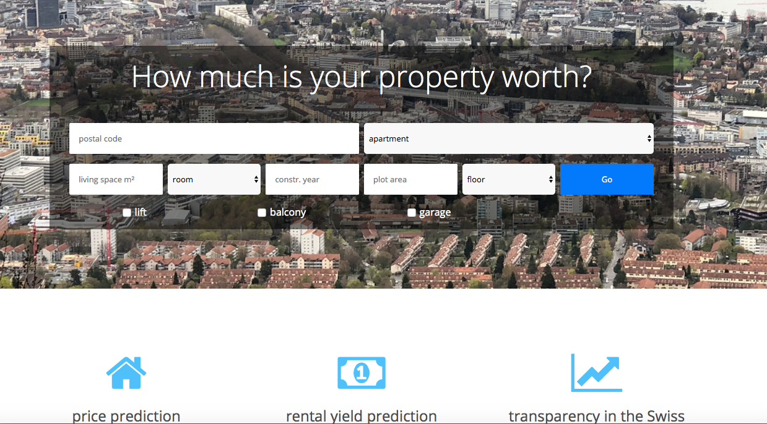

**How real estate is valued by banks?**

Resource: <https://www.credit-suisse.com/ch/en/articles/private-banking/wie-die-bewertung-einer-immobilie-funktioniert-201810.html>

Knowledge of how real estate is valued is indispensable, especially if you are buying or selling a property. A valuation may also be relevant when renewing your mortgage. However, numerous questions may arise in this regard. Read here about how real estate is valued.

**It is not the property itself that determines its value.**

The purpose of a real estate valuation is to determine the value of a property. That value is especially important when purchasing or selling property. In Switzerland, the valuation of a single family dwelling or a condominium reveals the market value of the property. The market value corresponds to the price that is likely to be obtained within a year under normal market conditions.

Basically, the real estate value is determined using two main components: the value of the land and the value of the building. The proportion that each of these two factors contributes to the total value of real estate can vary greatly from region to region. In urban centers, where the demand for residential property is consistently high due to the proximity to major cities such as Zurich or Basel, the land value accounts for a large part of the value of real estate. Conversely, in more sparsely populated, rural areas, the house or apartment itself will account for a larger proportion of the total value. Nevertheless, the land price is considered to be the main driver of price trends. And land prices, for their part, are influenced by a second factor in addition to proximity to cities: The lower the tax rates, the higher the price of the land and the property on it.

**Real estate valuation using the hedonic method**

The market value of a property can be calculated using various methods, some of which differ considerably. For example, owners can valuate their properties themselves using several online tools, by consulting experts from various institutions, or calling an appraiser. To value a single family dwelling or a condominium, Credit Suisse uses the hedonic method. This is a computer-assisted, comparative value method, based on a statistical process.

The hedonic method considers the purchase prices of properties with as many comparable features as possible. Key parameters in this process include the location, applicable tax multiple, property size, age, condition of the building, and other aspects of the property's quality. To calculate the market value of the property, experts analyze the parameters according to their weighting with the help of the valuation software.

**Be careful when using online tools**

Online tools allow you to assess a property's value for free in just a few clicks. All you have to do is enter details such as the address, floor area, year of construction and state of the property. These online tools provide you with an initial estimate of the value of the property. However, the results do not usually reflect the actual property value. Moreover, it is often unclear on which method the estimate is based.

**Calling in an expert**

Owners are usually not able to objectively assess a residential property, its condition, and official value. The owner's estimate of the property's market value tends to be too high. Bank experts or professional appraisers can calculate the true value of a property. Using their extensive expertise and experience, they are able to take individual features, such as antique construction elements or an unusual location, into account. A real estate valuation by a certified expert will cost about CHF 1,000.

**Get a second opinion**

If you have doubts about the initial valuation of the property, you should get a second opinion. Valuations of real estate may differ considerably, depending on the method used. It is better to be safe than sorry. Then you won't run the risk of nasty surprises when you buy or sell the property.

**Market value is not the same as purchase price**

The market value is the basis for the long-term financing of real estate. Therefore, it plays a crucial role in obtaining a mortgage. If the established market value differs from the asking price of the property, the mortgage will be calculated based on the lower of cost or market principle. This principle states that the lower of the two values shall always apply if the purchase price and the market value differ. So, if the market value is less than the purchase price, the maximum mortgage amount is lower. This means that purchasers must contribute a greater share of their own capital. This amount increases by the difference between the market value and the purchase price.

**Example:**

The market value of a single family dwelling was estimated to be CHF 850,000, but the purchase price is CHF 1,000,000. According to lower of cost or market principle, the mortgage will be calculated based on CHF 850,000. The buyer will have to finance the difference of CHF 150,000 between the market value and the purchase price entirely from his or her own funds. That increases the equity capital required from CHF 170,000 to CHF 320,000.

Purchase price

1,000,000

Market value 850,000

Mortgage (max. 80%) 680,000

Equity capital 170,000

Difference: purchase price to market value 150,000

Total equity capital 320,000

All amounts in Swiss francs.

**When it makes sense to revalue real estate?**

A property's market value changes over time. Basically, the value of the building gradually decreases. In order to maintain the value of a property in the long term, renovations frequently have to be undertaken. By contrast, the value of the property goes up if the price of the land increases or if the building gains added value. For example, adding a conservatory or building a pool can increase the value. The value also increases if demand exceeds supply, for example in urban centers such as Zurich or Geneva.

The bank may be carrying the property on its books at the original purchase price, especially if you have been living in the same place for a relatively long time. However, that is precisely the value on which calculations for repayment, interest, and the maximum loan-to-value ratio are based. If the market value has increased, a revaluation gives the owner more scope to finance any investment that may be required by increasing their mortgage. The market value of a property may also be crucial in the event of inheritance or divorce. Therefore, it can pay off to have a property reappraised from time to time.